Using Thonny

Using Thonny

In this specialization, you will learn to script in Python 3. For the first course of the specialization, we encourage you to use [CodeSkulptor3](https://www.coursera.org/learn/python-programming/supplement/idRw1/using-codeskulptor3), a browser-based environment designed to help beginning coders learn to program in Python 3. For the remaining courses in the specialization, you are required to use a desktop version of Python that has full support for reading and writing files as well as accessing popular packages.

This reading provides a brief overview of how to install and use Thonny. Thonny is a Python IDE designed for use by beginning Python coders. Thonny combines the installation of Python and an IDE into a single download while Thonny's user interface is simplified and easy to learn. Thonny also provides a built-in debugger that is helpful for debugging small Python programs. Note that you are not required to use Thonny in this specialization and that you are welcome to use another Python IDE such as [IDLE](https://www.python.org/downloads/) or [Atom](https://www.coursera.org/learn/python-programming/resources/fk7RB) as your desktop IDE of choice if you so desire.

Installing Thonny

Thonny is available at [thonny.com](http://thonny.org/). Clicking the appropriate download link at the top of the page will download an installer that installs both the latest version of Python and the Thonny IDE. Here are a couple of points of interest concerning this installation:

* For Mac users, we recommend that you move the resulting shortcut to Thonny to the Application folder. If you don't know where this folder is, you can use the Finder to locate it.
* Thonny places its Python installation in a special location that does not conflict with any current Python installations. This design avoids conflicts with existing installations. However, any packages that you have loaded in your previous Python installation will need to be reloaded from inside Thonny.

Once installed, a shortcut to run Thonny should appear on your desktop . Clicking this shortcut opens a window running Thonny that looks similar to the following:

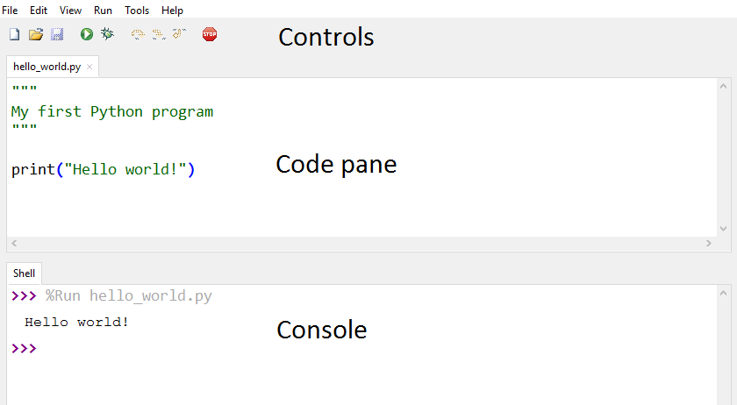

The main body of the Thonny window consists of a code pane (where you enter your Python code) in the upper part of the window and a console (where your Python program's output appears) in the bottom part of the window. Above the code pane are a sequence of buttons that control the basic functionality of Thonny appear. Above these buttons, at the top of the window, are standard pull-down menus that provides complete control of Thonny.

Writing programs in Thonny

The top code pane is the area where you will enter your Python code. Clicking in the area and typing will add code to the window. This area supports all of the common keyboard shortcuts that you may use in entering and editing your code. These shortcuts include:

* Copy (ctrl+c)
* Cut (ctrl+x)
* Paste (ctrl+v)
* Select all (ctrl+a)
* Undo (ctrl+z)

Thonny also supports more advanced editing operations such as block comments (alt+3) and block uncommenting (alt+4). A complete listing of these operations and their shortcuts are available in the **Edit** menu.

Saving programs in Thonny

Since Thonny runs on your desktop, saving your programs to the local file system is simple using the keyboard shortcut (ctrl+s). Note that Thonny requires you to save a new program before you run it for the first time. However, it doesn't require that you save your program after subsequent updates and runs.

Thonny also also you to edit several files simultaneously. In particular, you can open a new file (ctrl+N) using the **File** menu. You can switch between various open files using the tabs that appear above the code pane.

Running programs in Thonny

Once you are ready to run/test your code, clicking the green triangle button in the middle of the top row of controls causes Thonny to execute your Python 3 code. The output from your code (generated by print) is then displayed in the console at the bottom of the window. Clicking the red Stop sign button on right side of the the top row of buttons causes Thonny to terminate execution of your code and clear the console. Other options such as executing your program step by step in Thonny's debugger (as done in [Python Tutor](http://pythontutor.com/)) are also available in the **Run** menu.

**Locating errors:** When your Python code raises an error in Thonny, the resulting error message appears as blue hyperlinks in the console. Clicking on these links will take you directly to the line where the error has occurred (and the location of any function calls to the erroneous code). To help locate the line where an error took place, you also have the option of configuring Thonny to show line numbers using the **Options** sub-menu in the **Tools** menu.